A roll and write with a
cold draft.

1-6 Players ; 20 minutes

In Arctic Roll Players are a group of intrepid Inuit hunters, heading out across the ice to hunt for fish.
Using dice they move across the ice, dig ice holes, and fish. The dice are drafted and passed round the table. A common pool of calamities are rolled each round. Draft these early to avoid the worst consequences or leave it too late and find that you suffer a dreaded chasm collapse.

Each player takes a player sheet and adds 2 areas of open water.
To add an area of open water roll 2 dice. The 1st hex of open water is 2 hexes away from the centre, in the direction shown by the dice. The second hex is adjacent to the 1st hex in the direction shown by the 2nd dice.
The second area of open water cannot be in the same direction as the first (reroll if the same number is rolled). Add a Walrus to the 1st hex of the 2nd area of open water.
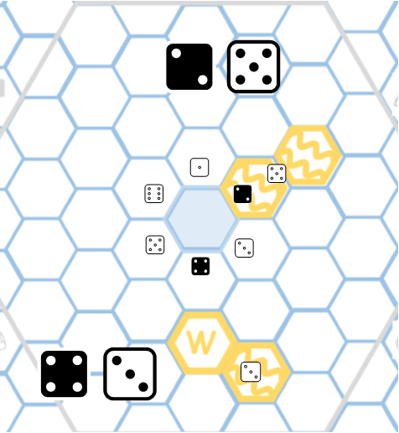

Each player then takes a player pawn and places it in the central hex of their sheet.

The player with the coldest hands is declared the start
player. The start player rolls as many black dice as there are players, placing them in the middle of the play area. These are the calamities.

Each player rolls 6 dice and places them on a diceflow in the middle of the table. They then choose one dice from the diceflow in front of them and add it to their player sheet.

Dice can be used in 3 ways.

Placement
- Draw the pips of the dice into the hex where the Pawn is standing (holes) or the surrounding hexes (for the hunters).
- Central pips (on 1,3,5) are ice holes around which fish can be hunted.
- Outside pips (on 2-6) represent hunters.
- Dice can be rotated into any orientation before placement.
- Nothing can be added to a hex that already has something inside it.
- If all the spots of the dice cannot be placed then the dice can not be used.

Movement
Move the pawn the number of hexes as there are pips on the dice.
Any movement;
- must be in a straight line.
- must finish on an empty hex.
- may not cross open water.
- may not take the pawn out of the play area— unless no other option is possible. (If the player piece is out of the area then they must use subsequent dice to move back into the area)

Choose a Calamity
- Starting with the start player players can choose to dispose of one dice on their dice flow and take one

of the Calamity Dice in the middle of the play area.
- Cross off a calamity counter on the player sheet. A player cannot take another calamity dice this round.
- If a player has not taken a calamity dice when they draft the 6th dice from a diceflow then they must take a calamity dice.
- The calamity dice is held until the end of the round.

The diceflows are then passed clockwise and another dice is drafted by each player.
Continue for 6 drafts (until the last dice is removed from each dice flow and added to the player sheets).

Each player then passes their player sheet and their calamity dice to the next player in the direction of play. This player places the calamity on their player sheet.
Calamities must be drawn into an empty hex. There are 6 types of calamity.
- Pack ice. Nothing else can be added to this hex.
- New Ice Flow. Add a new area of open water to the player sheet (2 hexes). This area cannot touch existing areas of open water and must be drawn into the central hexagon (within 3 hexes of the centre).
- Expand open water. Add 1 hex of open water to an existing area of open water.
When expanding an existing area of open water, 2 areas of open water can become joined together.
- Walrus. Walrus must be placed adjacent to an area of open water, expanding the area of open water by 1 hex. Any area of open water adjacent to a Walrus may not be fished.
- Polar Bear. Adjacent hunters do not hunt.
- Ice Chasm. Draw an arrow pointing towards an adjacent hex. Nothing on that hex will score at the end of the game.

When anything is placed in one of the 6 bonus hexes (player pawn, hunters, holes or calamity) the player can claim the bonus shown, by marking the relevant spot on the player sheet. Bonuses can be used immediately or at any point in a future turn.
- Igloo. The player can place 6 hunters around another hex.
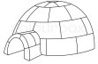
- New dice. The player can take another turn as though they had an extra dice of
any value they choose. This dice can be discarded to take a calamity dice.
- Reroll. The player claims a reroll which can be used to reroll all dice on a diceflow before picking dice.

When the round ends, pass the Calamity Diceflow to the next player. They become the start player for the next round. Each player then takes 6 dice and rolls them to place on their Diceflow and another round is played.
After 6 rounds the game ends and players score their dice sheets.

- Hunters that are adjacent to a dice hole or open water are able to fish there, and will score 1 point for each place they are able to fish.
- Score each hole or area of open water according to the number of hunters able to hunt there.

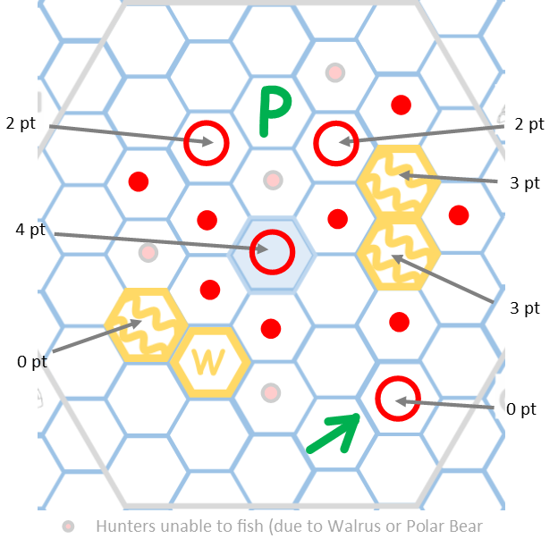

The player with the most points, wins the game. In the event of a tie then the player who has dug the most ice holes wins the tie.

Arctic Roll Solo is a solo variant of Arctic Roll which presents the individual player with a similar experience to playing Arctic Roll with other players.

1 x player sheet ; 6 x white dice ; 6 x black dice

Setup is the same as the regular game, but you will have to set up your own player sheet. You may find it easier to use a different coloured pen.
Take a player sheet and add 2 areas of open water.
To add an area of open water roll 2 dice. The 1st hex of open water is 2 hexes away from the centre, in the direction shown by the dice. The second hex is adjacent to the 1st hex in the direction shown by the 2nd dice.
The second area of open water cannot be in the same direction as the first (reroll if the same number is rolled).
Add a Walrus to the 1st hex of the 2nd area of open water.

Take a player pawn and place it in the central hex of

your sheet. Roll 6 Calamity Dice (black dice) and place them in front of you.

The game plays exactly the same way as the multiplayer game, but instead of drafting from dice ßows you reroll a decreasing number of dice from which to choose.
For the first dice placement, roll 6 dice and choose one
to add to your player sheet. Dice can be used in 3 ways. Placement
- Draw the pips of the dice into the hex where the Pawn is standing (holes) or the surrounding hexes (for the hunters).
- Central pips (on 1,3,5) are ice holes around which fish can be hunted.
- Outside pips (on 2-6) represent hunters.
- Dice can be rotated into any orientation before placement.
- Nothing can be added to a hex that already has something inside it.
- If all the spots of the dice cannot be placed then the dice can not be used.

Movement
Move the pawn the number of hexes as there are pips on the dice.
Any movement;
- must be in a straight line.
- must finish on an empty hex.
- may not cross open water.
- may not take the pawn out of the play area— unless no other option is possible. (If the player piece is out of the area then they must use subsequent dice to move back into the area)

Choose a Calamity
- You can choose to dispose of one rolled dice in order to take one of the Calamity Dice (black dice).
- Cross off a calamity counter on the player sheet. Put all the remaining calamity dice to the side. You will not take another calamity dice this round.
- If you have not taken a calamity dice when you choose your 6th dice then you must take the final calamity dice.

Instead of drafting from the same pool of dice the unused white dice are rerolled. The lowest numbered

calamity dice is removed.
If you choose a calamity dice then keep it until the end of the round, when 6 dice have been chosen. If a calamity dice has not been chosen then remove the lowest valued calamity dice from the pool of dice that remain.
Take the unused white dice and reroll them. You roll one less die each turn. On the 6th turn, you will roll a single die.

After you have chosen 6 dice you must place the calamity on your player sheet. Calamities must be drawn into an empty hex.
In the multiplayer game calamities are placed by a neighbour to provide the maximum inconvenience. There are suggestions as to how to do this below.
Iƒ you find yourselƒ ‘gaming’ this step to go easy on yourselƒ then ‘you do you’. There are 6 types of calamity.
- Pack ice. Nothing else can be added to this hex. Place this adjacent to as many hunters as possible, or adjacent to the player piece.
- New Ice Flow. Add a new area of open water to the player sheet (2 hexes). This area cannot touch existing areas of open water and must be drawn into the central hexagon (within 3 hexes of the centre). Iƒ this can be placed beside the player piece that is usually ‘unhelpƒul’. Iƒ not place it in an open area that is not adjacent to existing hunters.
- Expand open water. Add 1 hex of open water to an existing area of open water. When expanding an existing area of open water, 2 areas of open water can become joined together. Add this adjacent to a Walrus iƒ possible. Iƒ you can join 2 areas oƒ water together then do so.
- Walrus. Walrus must be placed adjacent to an area of open water, expanding the area of open water by 1 hex. Any area of open water adjacent to a Walrus may not be fished. Place this next to the area oƒ open water which already has the most hunters beside it.
- Polar Bear. Adjacent hunters do not hunt. Place this in a hex adjacent to the maximum number oƒ hunters possible.
- Ice Chasm. Draw an arrow pointing towards an adjacent hex. Nothing on that hex will score at the end of the game. Iƒ you have prepared a careƒul plan ƒor ƒuture turns then kill it!

When anything is placed in one of the 6 bonus hexes (player pawn, hunters, holes or calamity) you can claim the bonus shown, by marking the relevant spot on the player sheet. Bonuses can be used immediately or at any point in a future turn.
- Igloo. You can place 6 hunters around any other hex.
- New dice. You can take another turn as though they had an extra dice of any value
they choose. This dice can be discarded to take a calamity dice.
- Reroll. Claim a reroll which can be used to reroll all the dice before you choose one.
After 6 rounds (of choosing 6 dice) the game ends and you score your player sheet.

- Hunters that are adjacent to a dice hole or open water are able to fish there, and will score 1 point for each place they are able to fish.
- Score each hole or area of open water according to the number of hunters able to hunt there.
- Add them up to give you a total score.

You may keep your player sheets to see how your score compares with previous games. Anything over 60 points is pretty good!

Dice Placement Calamity

x

+1

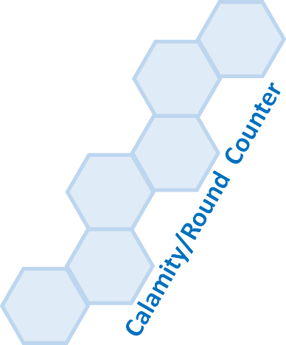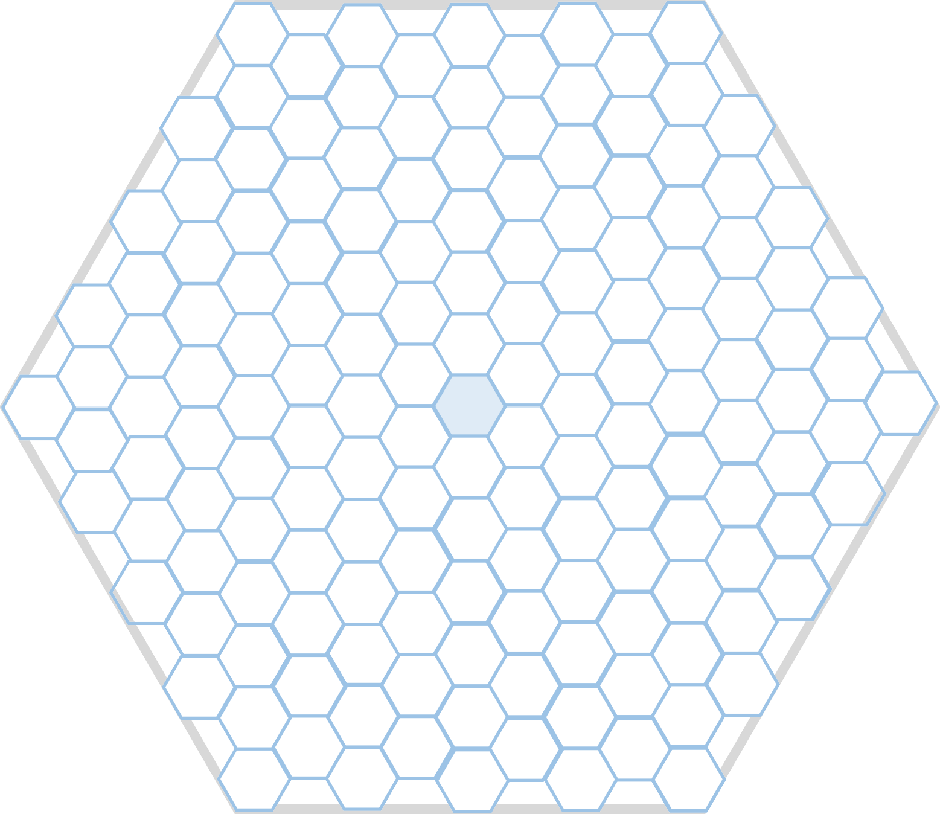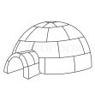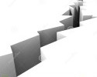

?
Reroll before pick
6

5
W
4
3 P

1 2
lan Brocklebank ian@thegamespeople.co.uk

